**COMP-1295 Information Systems**

**Windows 10 Installation and Configuration Instructions**

Download an evaluation copy of Windows 10 64-bit from the Microsoft site.

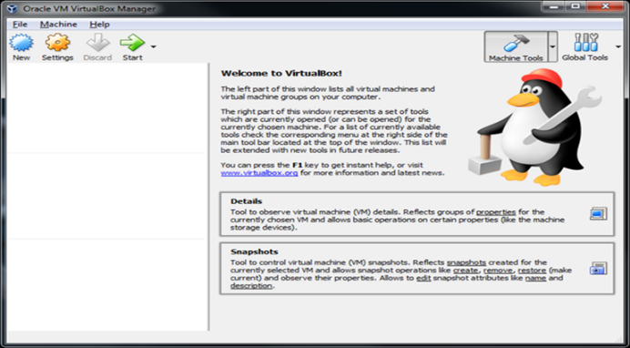

To create a new virtual machine, click the **New** button in the VirtualBox.

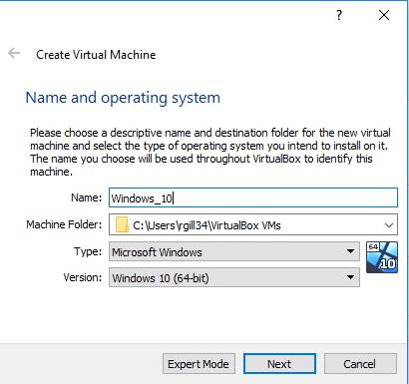

The New Virtual Machine Wizard will launch, prompting you to enter a name for this virtual machine. Set the VM name to **Windows_10.**

VirtualBox should update the Operating System Type and Version information automatically. If not, update it manually so it matches this screen. Click Next.

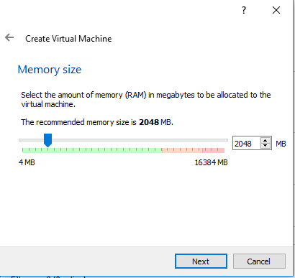

Leave the base memory size to 2048 MB. Click Next.

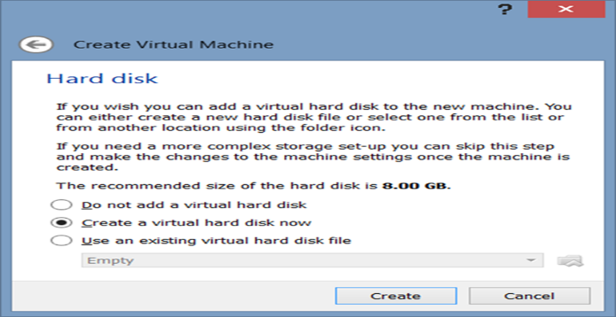

Next we need to add a virtual hard drive. Select ‘Create a virtual hard disk’ and click Create.

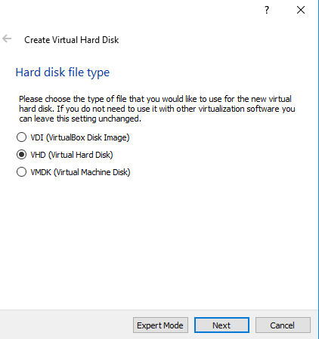

VirtualBox can create virtual hard drives in several different formats. Select VHD (Virtual Hard Disk). Click **Next.**

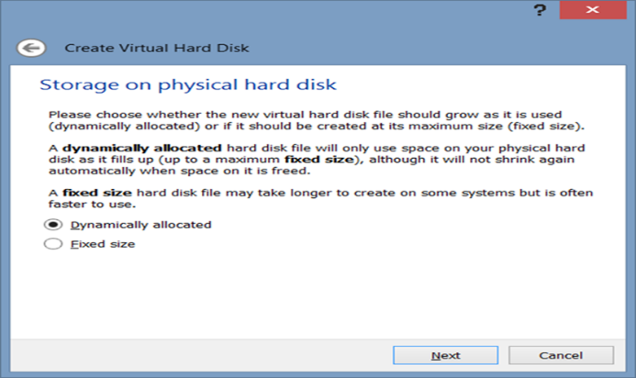

Select how space for the hard drive will be allocated. Select **Dynamically allocated**. This means that space for the virtual hard disk will allocated on the physical drive as required. Note that space will not be automatically released once it has been allocated to the virtual hard drive. The only way to release space is to recreate the hard drive. Click **Next**.

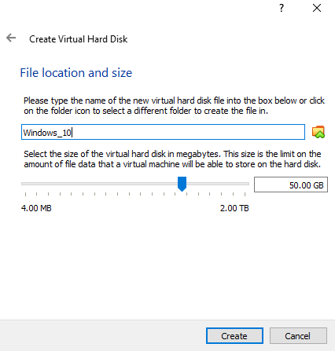

Do not alter the storage location. Update the disk size to 50 GB if necessary.

Click the **Create** button.

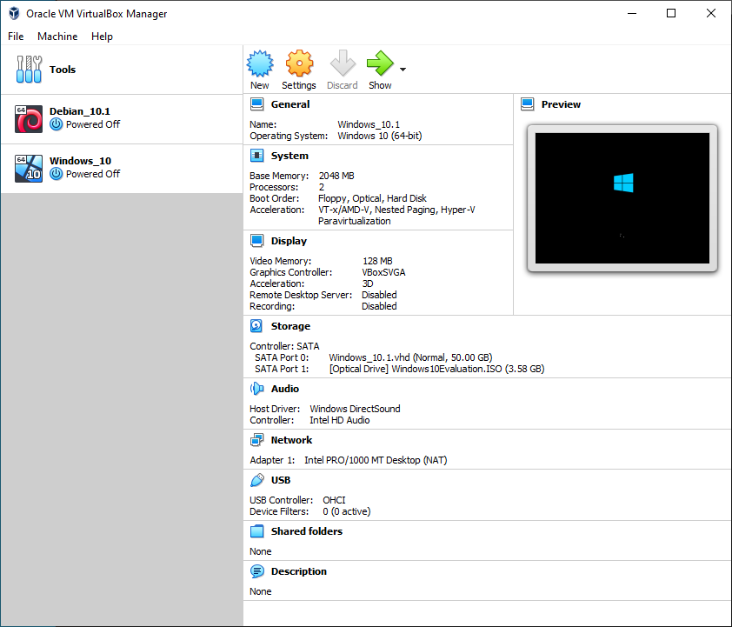You should now be presented with the Oracle VM VirtualBox Manager. On the toolbar, click on the **Settings** button.

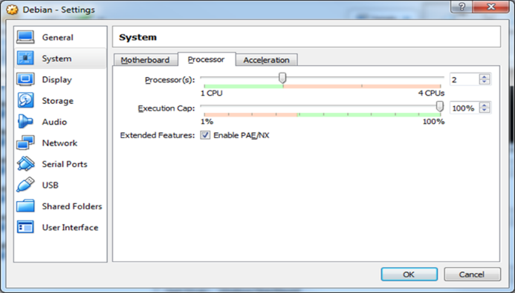

1) Click on the System heading in the right hand pane.

Select the processor tab and increase the number of processors to 2.

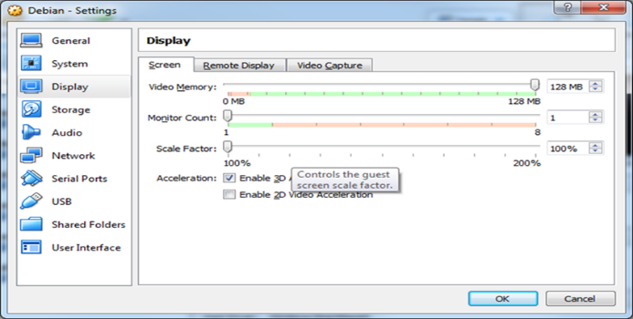

2) Next, select Display from the left-hand pane.

Update Video Memory to 128 MB and enable 3D acceleration.

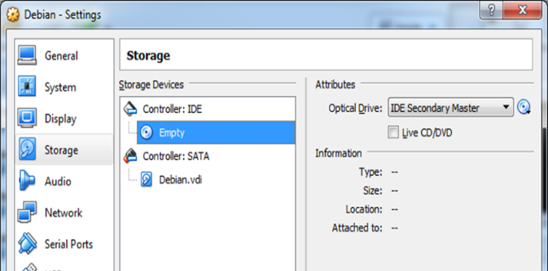3) Click on Storage in the left hand pane.

Attach your Windows 10 Evaluation ISO file to the CD/DVD drive:

* Select the empty IDE controller
* Click the disk icon on the upper right.

The following window should appear:



* Select ‘Choose Virtual Optical Disk File…’
* Find and select your Windows 10 Evaluation ISO file
* Click OK once these settings have been updated.

**Windows Installation:**

Click the Start button to start the new virtual machine. Windows installation process will begin automatically.

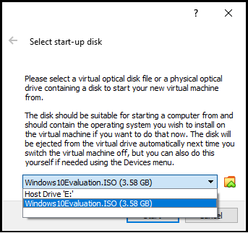

You might be asked to select the startup disk. If you are, be sure to select the Windows Evaluation ISO file.

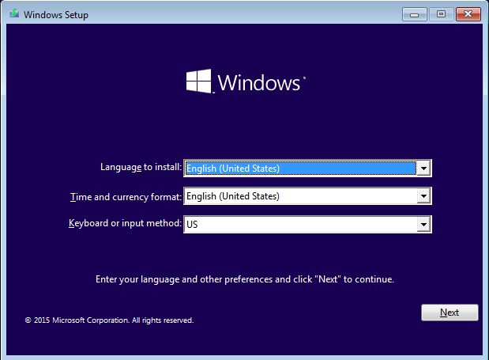

The install will start and present you with the following screen: Click **Next** to accept the defaults.

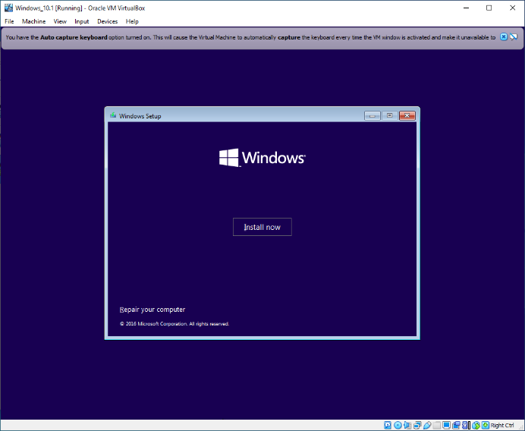

Choose **Install Now.**

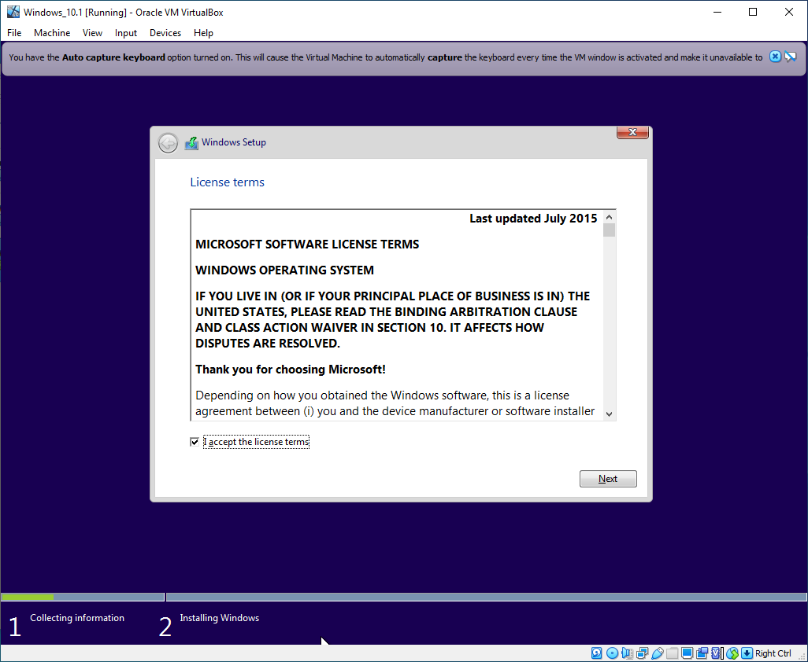

Accept the license agreement.

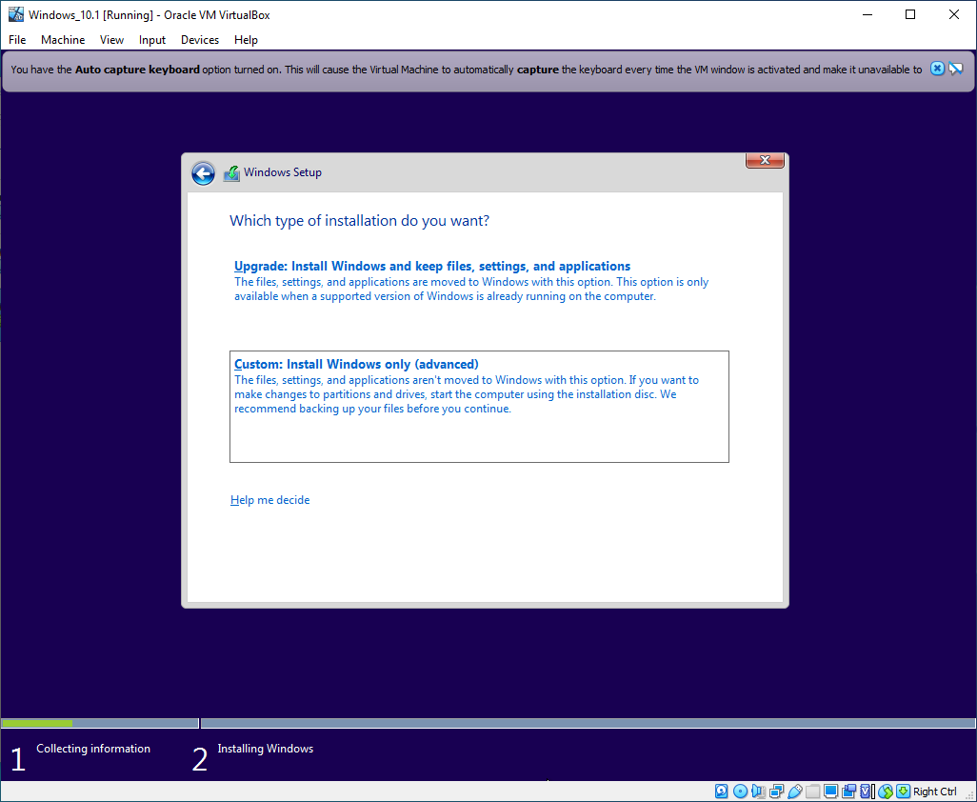

Choose custom install.

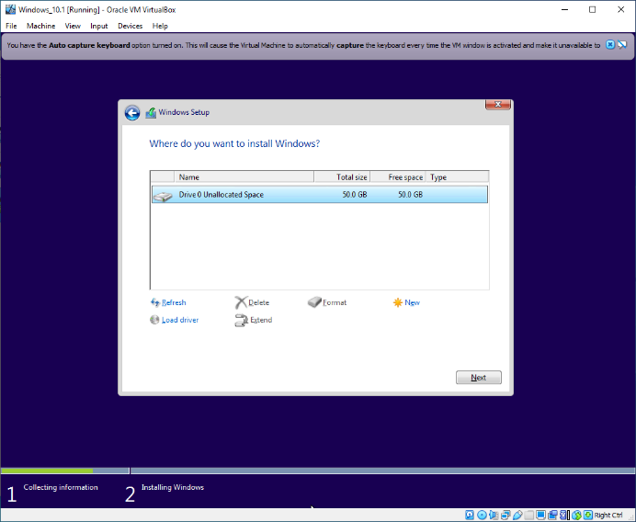

Accept the default disk.

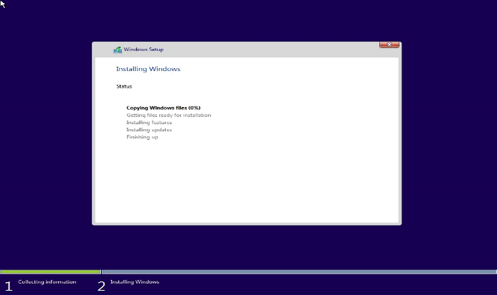

This screen presents the status of Windows installation. This is the longest part of the Windows install, and can easily take 30+ minutes to complete.

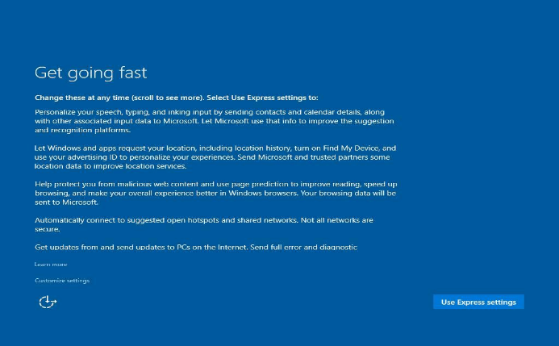

Once the system boots use express settings.

This also takes a bit of time.

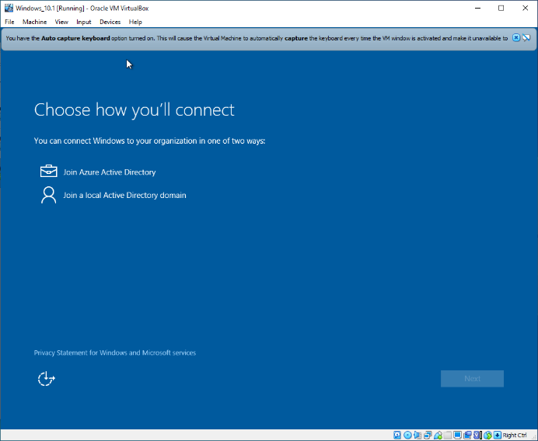

Identify how to connect to the Windows machine – choose ‘Local Active Directory Domain’.

Setup will advise you it will create a local ID that can be added to a domain later. We only need the local ID. Click ‘**Next**’.

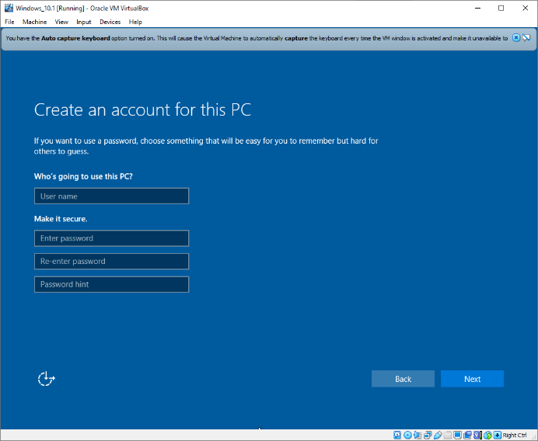

Create a user account with your first name and set password as Password01. Click ‘**Next**’ to complete Windows installation.

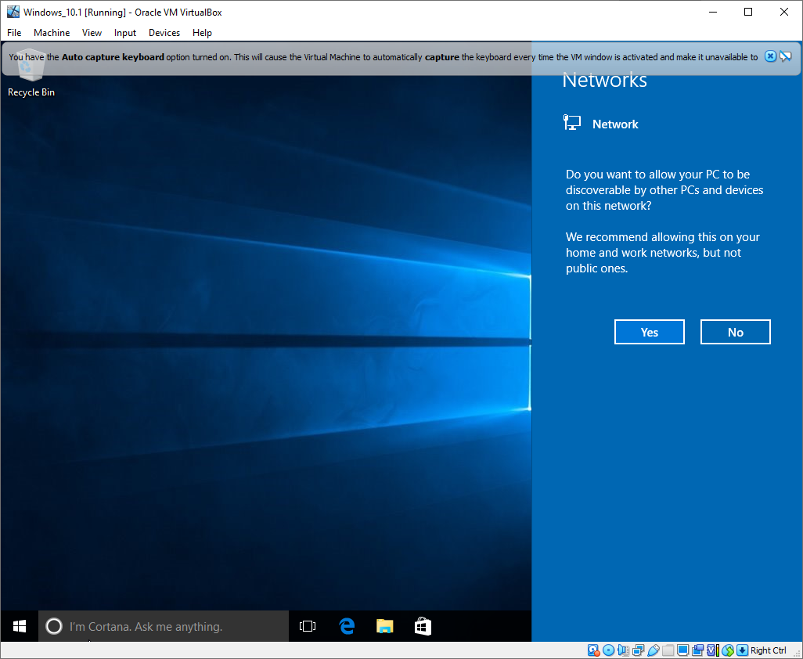

Windows will ask if you want your PC to be discoverable. Choose ‘No’.

Windows is now installed!